

Experiment No. 4

Title: Virtual lab on Part-of-Speech Tagging using Hidden Markov Model
Batch: NLP–1 Experiment No.: 04

Roll No.: 16010422234 Name: Chandana Galgali
______________________________________________________________________________

Aim of the Experiment: To explore the virtual lab on Part-of-Speech Tagging using Hidden Markov Model
______________________________________________________________________________

Program/Steps:
1. Perform the virtual lab experiment to calculate the Transition Probability Matrix and Emission Probability Matrix for all the given corpuses
______________________________________________________________________________

Output/Result:
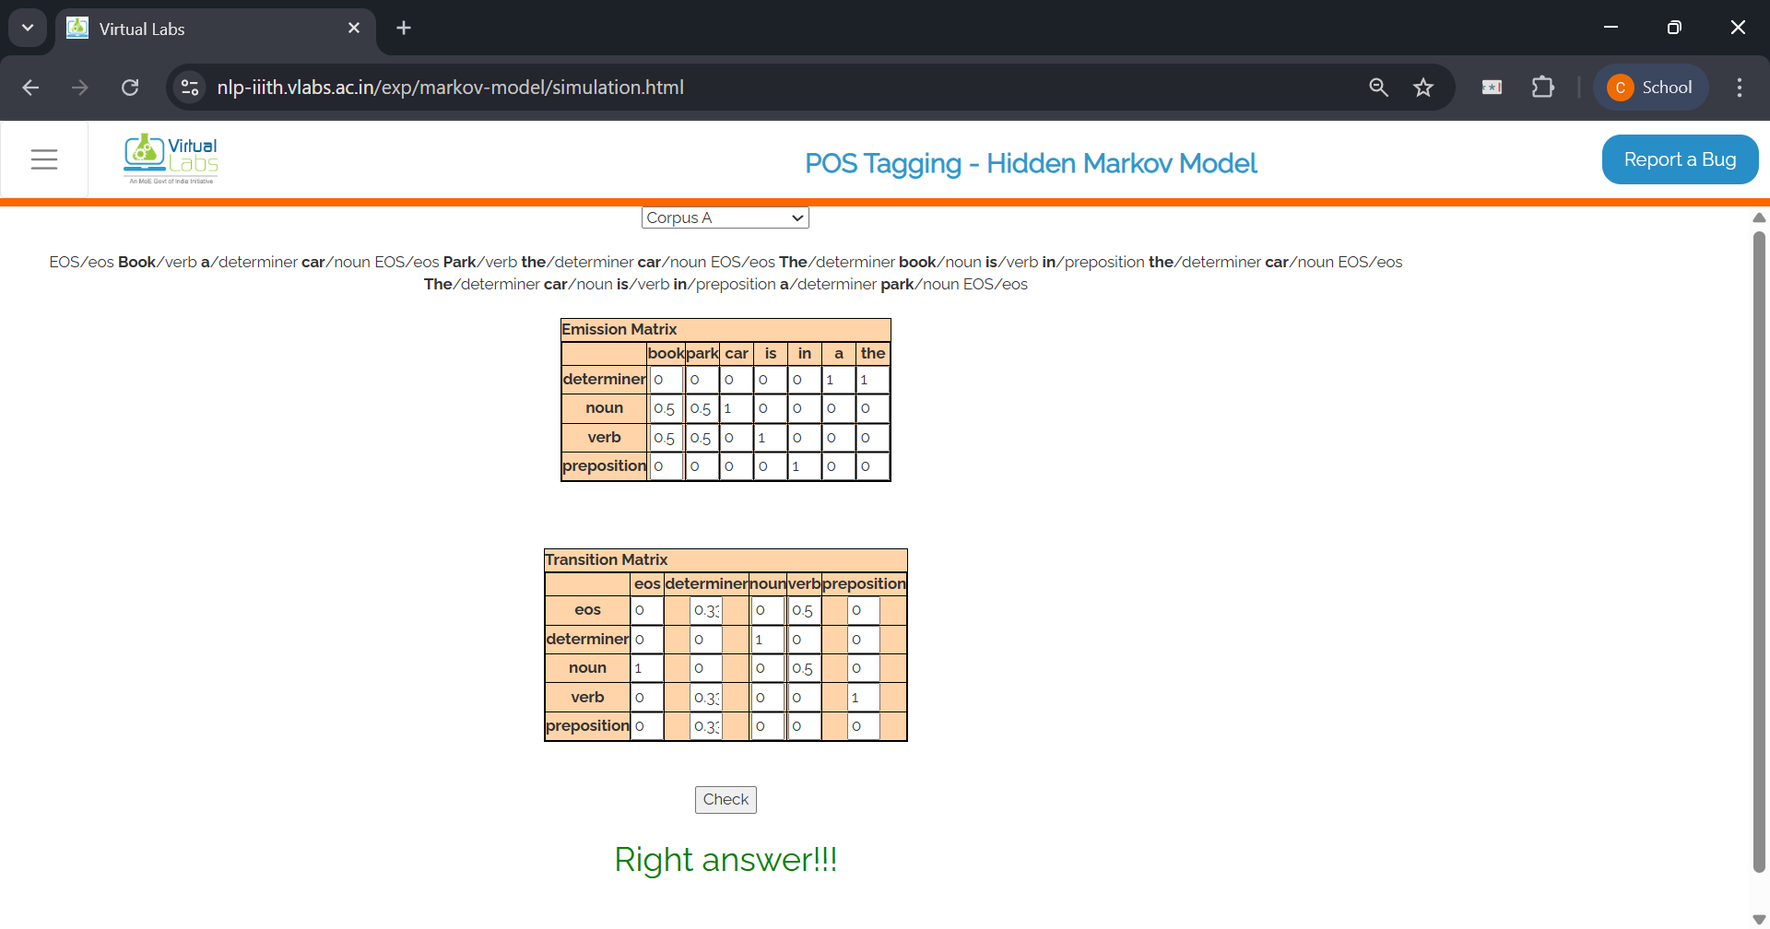
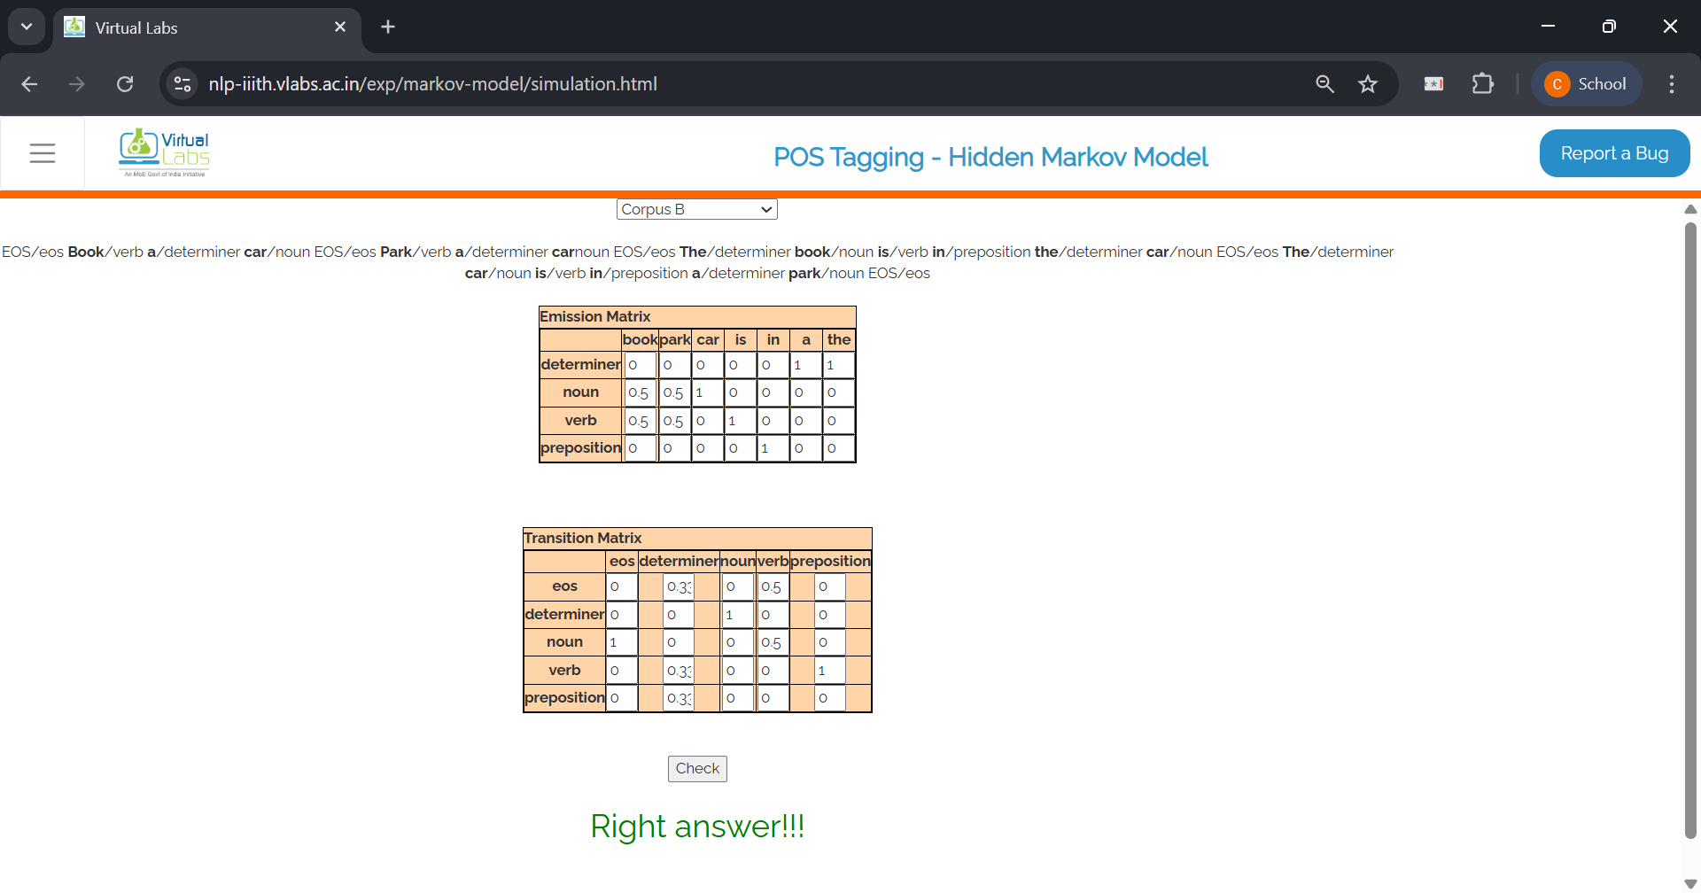
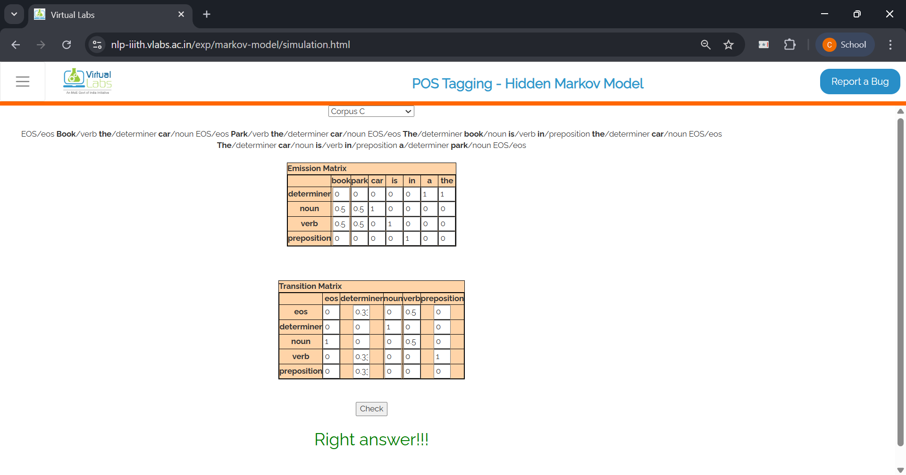
______________________________________________________________________________

V Lab Assignment:

1. How is Hidden Markov Model different from Markov Model?
Ans: Markov Model: The states are directly observable, and the next state depends only on the current state (Markov property). Hidden Markov Model (HMM): The states are hidden (not directly observable), and only observations generated from these states are visible. In POS tagging, the hidden states are POS tags, and the observations are the words.

2. What is the basic design for HMM for finding out POS?
Ans: The following is the basic design for HMM for finding out POS:
- Hidden States: POS tags (e.g., Noun, Verb, Determiner, etc.).
- Observations: Words in the sentence.
- Transition Probability Matrix: Probability of moving from one POS tag to another.
- Emission Probability Matrix: Probability of a word being generated from a POS tag.
- Algorithm: Use these probabilities with a decoding algorithm (e.g., Viterbi) to find the most likely sequence of POS tags for a sentence.

3. What are the basic assumptions for the above model?
Ans: The basic assumptions are follows:
- Markov Assumption: The current POS tag depends only on the previous POS tag (first-order dependency).
- Output Independence Assumption: A word depends only on its own POS tag and not on surrounding words.
- Stationarity: Transition and emission probabilities remain constant across the sequence.

4. How does the corpus size affect the transition and emission matrix?
Ans: Small corpus: Probability estimates may be unreliable or zero for rare events, leading to sparsity in the matrices. Large corpus: More accurate and stable probability estimates, better coverage of word–tag and tag–tag combinations, resulting in improved POS tagging accuracy.
______________________________________________________________________________

Post Lab Question-Answers:
- Explain the difference between Transition Probability Matrix and Emission Probability Matrix for POS Tagging using HMM.
Ans: Transition Probability Matrix:
- This matrix represents the probability of moving from one POS tag (hidden state) to another in a sequence. It captures the syntactic structure of the language — for example, how likely a Noun is followed by a Verb. Mathematically, it is P(tag_t | tag_(t-1)).
- Example: P(Verb | Noun) = 0.35.
Emission Probability Matrix:
- This matrix represents the probability of a word (observed state) being generated from a particular POS tag (hidden state). It captures the relationship between tags and actual words in the corpus. Mathematically, it is P(word_t | tag_t).
- Example: P("run" | Verb) = 0.60.
In short:
- Transition Probability → tag-to-tag likelihood (sequence structure).
- Emission Probability → tag-to-word likelihood (word generation).
______________________________________________________________________________

Outcomes: CO3 – Establish concept of Structure and Semantics
______________________________________________________________________________

Conclusion (based on the Results and outcomes achieved):
In this experiment, we successfully explored the working of POS tagging using a Hidden Markov Model and calculated both Transition and Emission Probability Matrices for the given corpora. The results demonstrated how HMM uses transition probabilities to model the likelihood of one POS tag following another, and emission probabilities to link POS tags with actual words. This understanding is crucial for building accurate POS taggers and other sequence labeling applications in NLP.
______________________________________________________________________________

References:
Books/ Journals/ Websites:
- Allen James, Natural Language Understanding, Benjamin Cumming, Second Edition, 1995
- Jurafsky, Dan and Martin, James, Speech and Language Processing, Prentice Hall, 2008
- Palash Goyal, Karan Jain, Sumit Pandey,Deep Learning for Natural Language Processing: Creating Neural Networks with Python, Apress, 2018
______________________________________________________________________________

